How to Search on the Residents Website

Searching is a way to connect you with what you want to find on the KoH Residents Website. In Part One this guide describes how to do a search and Part Two provides a table suggesting words to use for finding some commonly sought pages

Part One: How to Do a Search

- Go to the search box at the top and bottom of the HOME page and at the very bottom of all other pages. It looks like this:
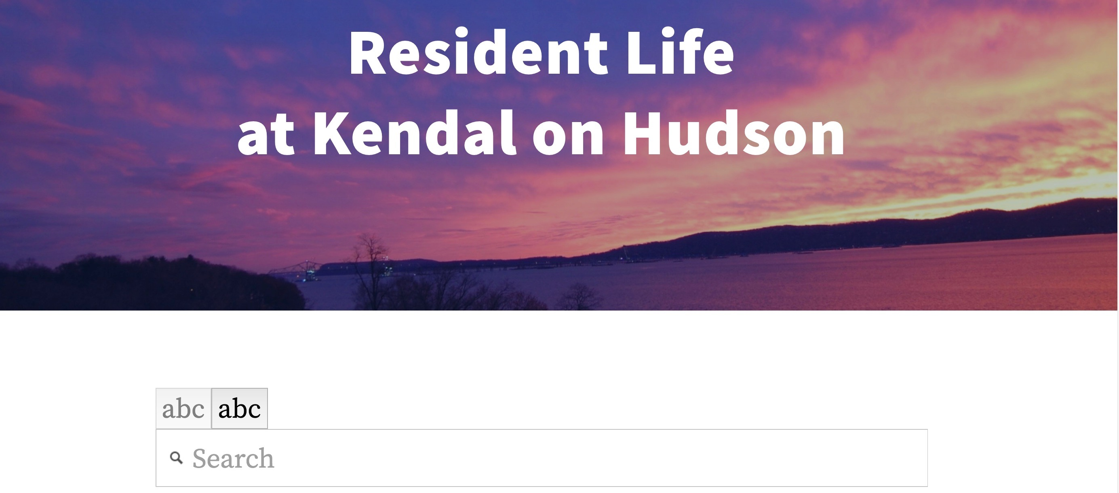
Search
Box

- Enter the word/s that describe your need in the box (see search suggestions for the KoH Residents Website in the Table below.

- Click on Enter. Example:

Search Results ReResultss
Search Results
Search Term
- Review the suggestions that appear.
- Click on the result that looks most promising.
- If it isn’t what you want, press return arrow.
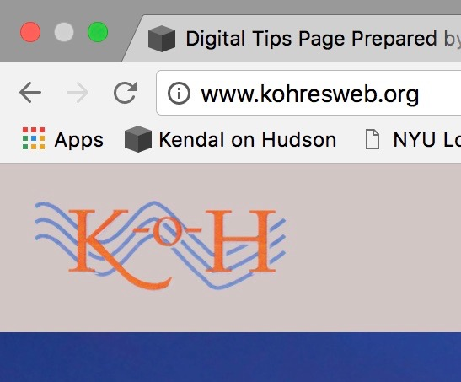

- Try other suggestions
- Press return arrow until you return to the search window.
- Try other search words.

